**SCHOOL OF ENGINEERING**

**(Far Western University)**

**Mahendranagar , Kanchanpur**



**[ Subject Code : CT 125]**

A MINOR PROJECT PROPOSAL ON

**Block-Games**

A Proposal submitted for the minor project on Block-Games by using object oriented programming

concepts by the students of Bachelor of Computer Engineering Students

(Second Semester)

|  |  |
| --- | --- |
| **Submitted By:**  **Anuradha Bhatt 3**  **Dipa Joshi 12**  **Dipak Raj Giri 13**  **Menuka Paneru 25** | **Submitted to:**  **Er.Birendra Singh Dhami**  **from**  **Department of Engineering,FWU** |

**02/2079**

# ABSTRACT

Block-games is a computer action game, whose goal is to provide an intelligent board to response to the actions by user . In this we develop a board based on side selection functions considering smoothness ,different color for different objects, and representative symbol. Scores given by the functions are aggregated by sum of total blocks , and the player who makes the more number of blocks will be th winner. To perform these tasks we examine several algorithm variants of different crossover and environmental selection operators. And if needed overloaded operators too.

# ACKNOWLEDGEMENT

The success of this project required a lot of guidance and assistance from many people and we are extremely fortunate to have got this all along the completion of our second semester project work whatever we have done is only due to t0 such guidance and we would not forgot to thank them. Firstly, we would like to thank institute of engineering for including the project work as the part of curriculum which helps to explore our knowledge practically. Then special thanks to our programming-teacher Er. Birendra Singh Dhami whose valuable guidance has been the one that helped us to patch this project and make it easier. His suggestion and instruction has served as the major contributor toward the completion of execution module of this project. Last but not the least we would like to thank to the department of computer engineering and HOD Er . Toran Prashad Bhatt for providing us with all faculty that was required.

Table of Contents

ABSTRACT ii

ACKNOWLEDGEMENT iii

LIST OF FIGURES v

INTRDOUCTION 1

1.1 Background 1

1.2 Problem statement 2

1.3 Objectives 3

1.4 Application 3

1.5 Game Features 3

1.6 Feasibility Analysis 4

**1.6.1 Economic Feasibility** 4

**1.6.2 Technical Feasibility** 4

1.7 System Requirements 4

**1.7.1 Hardware Requirements** 4

**1.7.2 Software Requirements** 4

LITERATURE REVIEW 5

2.1 Paper Pencil Game 5

2.2 Game Development 5

METHODOLOGY 7

3.1 Analysis 7

3.2 Process 7

EPILOUGE 10

4.1 Project Members 10

4.2 Expected Outcomes 10

4.3 Work Schedule 10

REFERENCES 11

Website’s links 11

# LIST OF FIGURES

**Figure 1 (2,2) Dots and Boxes game** 2

**Figure 2 Tic Tac Toe** 6

**Figure 3 GameBoard** 7

**Figure 4 GameBoard** 8

**Figure 5 GameBoard** 8

**Figure 6 GameBoard** 9

**Figure 7 GameBoard** 9

**Figure 8 GameBoard** 9

**Figure 9 GameBoard** 10

**Figure 10 Working Schedule** 11

**CHAPTER 1**

## INTRDOUCTION

## Background

**BG** stands for BlockGames.This game is modified version of **Dots and Boxes** game.This is two player paper pencil game with two different representative symbols as for an example let us take knought and cross.The player who succeeds in making more number of blocks in the given play board wins the game.It is an example of zero-sum game i.e. one persons gain is equivalent to another loss.

Lets us first know about Dots and Boxes game .This game was invented by French Mathematician Edward Lucas in 1891,who called it ***pipopipette***. **Dots and Boxes** is a two player(sometimes more) game that using paper and pencil. At earlier time, this game is very popular in European, being taken as the project of international computer Olympic tournament game . It has gone by many other names, including the **dots and dashes**, **game of dots**, **dot to dot grid**, **boxes**,[]](https://en.wikipedia.org/wiki/Dots_and_Boxes#cite_note-5) and **pigs in a pen**.

The game starts with an empty grid of dots. Usually two players take turns adding a single horizontal or vertical line between two unjoined adjacent dots. A player who completes the fourth side of a 1×1 box earns one point and takes another turn. A point is typically recorded by placing a mark that identifies the player in the box, such as an initial. The game ends when no more lines can be placed. The winner is the player with the most points.The board may be of any size grid. When short on time, or to learn the game, a 2×2 board (3×3 dots) is suitable. A 5×5 board, on the other hand, is good for experts.

The diagram below shows a game being played on a 2×2 board (3×3 dots). The second player ("B") plays a rotated mirror image of the first player's moves, hoping to divide the board into two pieces and tie the game. But the first player ("A") makes a *sacrifice* at move 7 and B accepts the sacrifice, getting one box. However, B must now add another line, and so B connects the center dot to the center-right dot, causing the remaining unscored boxes to be joined together in a *chain* (shown at the end of move 8). With A's next move, A gets all three of them and ends the game, winning 3–1.

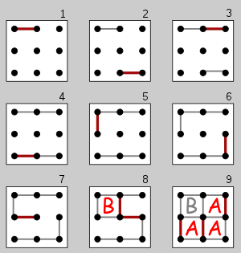

**Figure 1 (2,2) Dots and Boxes game**

So now we have taken some changes to represent it in graphical board and make it easier to play and look attractive .We have named Blockgames to the to this project.The changes will be discussed in methology section.

## 1.2 Problem statement

Now the problem is to design the BlockGames which provides following functionalities:

* Both the players can choose any line (except the line already chosen) on their respective turn.
* A box should be completed when the its four sides are selected.
* The point should given to the player who makes the complete box and when any player makes an box he will get a bonus chance too.
* The respective symbol should be printed when a player completes a box.

The required class are:

* Board
* Player

And some other if required on development phase.

## 1.3 Objectives

* To make this game playable in computer.
* To make the game easy to play.
* To make the game look attractive.
* To show the concepts of OOP and C++ how it is used in real world problems.

## 1.4 Application

* It will be used for entertainment purpose by kids sometimes youths too.
* It will be by the student to study concepts of OOP and C++.
* It will be used by programmers to create game similar to it having some additional things.

## 1.5 Game Features

* This game will have welcome animation.
* This game allow players to enter their name
* This game will provide toss mechanism for the player for the first turn
* This game will itself count the points of each players and declare winner itself.

## 1.6 Feasibility Analysis

### **1.6.1 Economic Feasibility**

This game is made with simple and basic concepts of OOP so there is no any funding needed to complete this we can build it easily without investment. Since the game is focused for entertainment of children’s and anyone can access it without any cost paying.

### **1.6.2 Technical Feasibility**

Basically this game has two parts : Logical operations and pictorial representation .Here we can use OOP concept with C++ to perform logical operations and for pictorial representation we can use graphics .h header file with the compile tdm_gcc32 bit with code blocks ide(any other too like vs code etc.)

## 1.7 System Requirements

### **1.7.1 Hardware Requirements**

* Processor: 1.4 Ghz,32 bit or more
* Ram: 512MB or more
* HDD or SSD: compatible with processor
* Display: (700 x 750) Capable video adapter and monitor

### **1.7.2 Software Requirements**

* Operating system: windows 7, windows 10, windows 8, windows xp
* Compiler tdm_gcc 32 bit (included graphics .h)
* IDE:Codeblocks,Vscode,dev c++,turbo C++ etc.

**CHAPTER 2**

# LITERATURE REVIEW

## 2.1 Paper Pencil Game

Paper-and-pencil games or paper-and-pen games (or some variation on those terms) are [games](https://en.wikipedia.org/wiki/Game) that can be played solely with [paper](https://en.wikipedia.org/wiki/Paper) and [pencils](https://en.wikipedia.org/wiki/Pencil) (or other [writing implements](https://en.wikipedia.org/wiki/Writing_implement)), usually without erasing. Some popular examples of pencil-and-paper games include [Tic-tac-toe](https://en.wikipedia.org/wiki/Tic-tac-toe), [Sprouts](https://en.wikipedia.org/wiki/Sprouts_(game)), [Dots and Boxes](https://en.wikipedia.org/wiki/Dots_and_Boxes), [Hangman](https://en.wikipedia.org/wiki/Hangman_(game)), [M.A.S.H.](https://en.wikipedia.org/wiki/MASH_(game)), [Paper soccer](https://en.wikipedia.org/wiki/Paper_soccer), and [Spellbinder](https://en.wikipedia.org/wiki/Spellbinder_(paper-and-pencil_game)). The term is unrelated to the use in [role-playing games](https://en.wikipedia.org/wiki/Role-playing_game) to differentiate [tabletop games](https://en.wikipedia.org/wiki/Tabletop_role-playing_game) from [role-playing video games](https://en.wikipedia.org/wiki/Role-playing_video_game).

[Board games](https://en.wikipedia.org/wiki/Board_game) where pieces are never moved or removed from the board once being played, particularly [abstract strategy games](https://en.wikipedia.org/wiki/Abstract_strategy_game) like [Gomoku](https://en.wikipedia.org/wiki/Gomoku" \o "Gomoku) and [Connect Four](https://en.wikipedia.org/wiki/Connect_Four), can also be played as pencil-and-paper games.

# 2.2 Game Development

Game Development is **the art of creating games and describes the design, development and release of a game**. It may involve concept generation, design, build, test and release .Generally now days games are build in game development softwares like **Unity ,Godot ,GameMaker ,Amazon Lumberyard** etc.There is now days all the games are developing for computers i.e. playable on computer devices. Tic tac toe is the game mostly developed by beginners .Tic tac toe is (3,3) board game which is generally build with the concept of array or string or linked structure (using self referential class).

The game which we are going to build is not so much familiar for beginner developers though there are some developers who had developed this game using javascript , python .Since we are in coding and we don’t have understanding of these programming languages , we don’t have any reference for coding .But we have found form other game projects that for graphics we can use graphics.h library ,SDL ,OpenGl ,Allegro ,Cinder ,SFML etc. Out of these graphics.h is easy to use for beginners and it helps beginners to have good understanding of Pixels ,Graphics . Graphics.h library is not available in the modern compilers but we can add it and easily use it whereas other libraries provides more features but they are not beginner friendly.

Tic Tac Toe game Using grapics.h library:

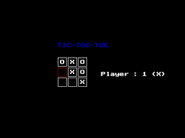

**Figure 2 Tic Tac Toe**

**CHAPTER 3**

# METHODOLOGY

## 3.1 Analysis

Following are the important points after analysis:

* To build this game we are going to use C++ with graphics.h library.
* To make board we will need shape making classes for creating rectangle, square etc .with required color.
* To store different entities we will need objects or object array or object pointers of required class.
* We have to write the logic to perform the actions.

## 3.2 Process

The game work will be as:

* The welcome animation welcomes the players
* Selection of player 1 and player 2
* Start of game and continues as follows:

The board will look like as below at the beginning of the game,

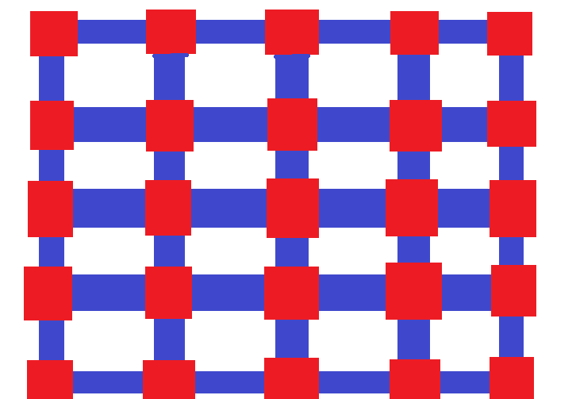

**Figure 3 GameBoard**

Then according to the players selection of side the game will go as

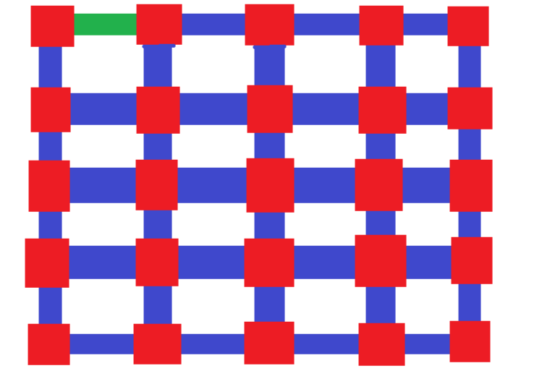

**Figure 4 GameBoard**

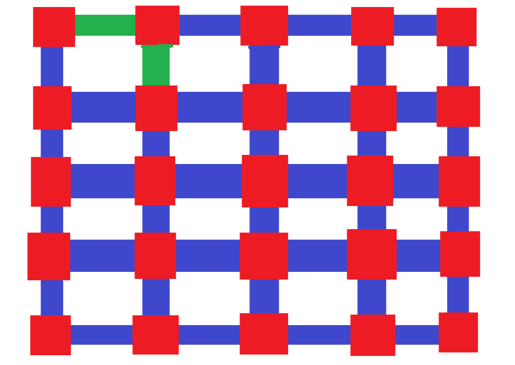

**Figure 5 GameBoard**

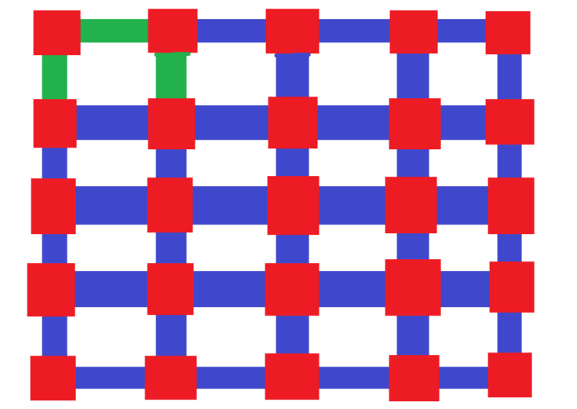

**Figure 6 GameBoard**

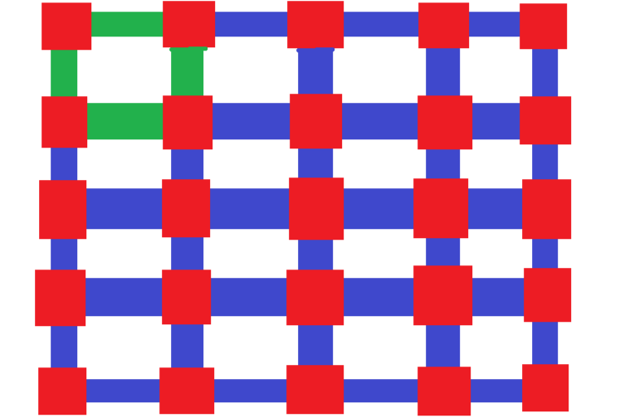

**Figure 7 GameBoard**

In this we when a block or box is formed then the respective player get a point and will be shown as,

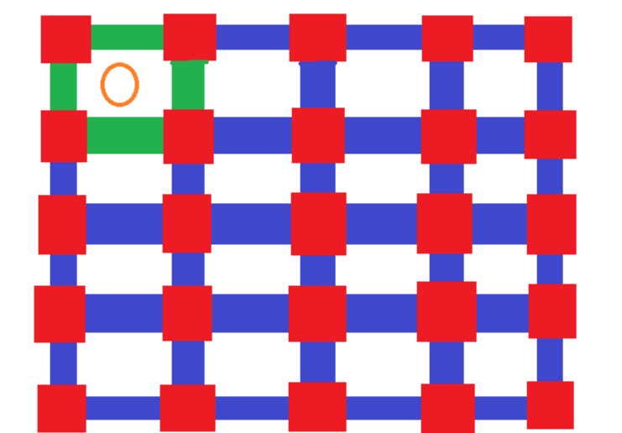

**Figure 8 GameBoard**

The the game will continues until all sides will not be selected and finally the board will look like

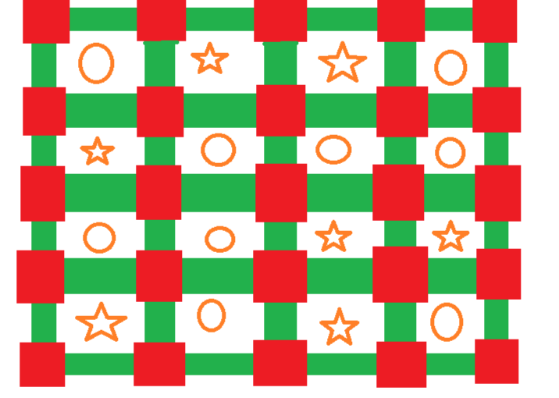

**Figure 9 GameBoard**

The the winner selection logic will calculate who is the winner and the board will be ready for next game.

**CHAPTER 4**

# EPILOUGE

## 4.1 Project Members

**1.Anuradha Bhatta (BCE second semester)**

**2.Dipa Joshi (BCE second semester)**

**3.Dipak Raj Giri (BCE second semester)**

**4.Menuka Paneru (BCE second semester)**

## 4.2 Expected Outcomes

* First of all game should run smoothly.
* The game would not have run time errors.
* The game would be attractive.
* The game would provide the features discussed above.

## 4.3 Work Schedule

**Figure 10 Working Schedule**

# References

Agrawal, D. (n.d.). *setfillstyle() and floodfill() in C*. Retrieved from GeeksforGeeks: https://www.geeksforgeeks.org/setfillstyle-floodfill-c/

*Dots and Boxes*. (n.d.). Retrieved from Wikipedia: https://en.wikipedia.org/wiki/Dots_and_Boxes

Li, S., & Yuan, X. (n.d.). *Technique Analysis of Dots-and-Boxes*. Retrieved from ResearchGate: https://www.researchgate.net/publication/301454149_Technique_Analysis_of_Dots-and-Boxes

Main, M. (2008, september). *Using the WinBGIm Graphics Library with Dev-C++*. Retrieved from Colorado: https://home.cs.colorado.edu/~main/bgi/dev-c++/

Prasad, R. (2020, May 1). *01. Introduction to C/C++ graphics.h tutorial series | CodeWar*. Retrieved from CodeWar: https://www.youtube.com/watch?v=r7yOMz8HrHk

spielen, K., & puntos, j. c. (2022, February 16). *How to Play Dots and Boxes*. Retrieved from WikiHow: https://www.wikihow.com/Play-Dots-and-Boxes

Computer game is an important research subject of artificial intelligence, and the development of

artificial intelligence itself mainly profit from the development of computer game researches, in

which, the notable events in 1997 of Deep Blue beat Garry Kasparov, the world chess champion,

became one important milestone [1]. Invented in 1891 by Edward Lucas, one French mathematician,

Dots-and-Boxes[2] is a two player game that using paper and pen. At earlier time, this game is very

popular in European, being taken as the project of international computer Olympic tournament game.

By now, many well-known international institutions have taken part in the development of related

software for Dots-and-Boxes, for example, Elmo Timoteus with the Mathematics Department of

UCLA (University of California at Los Angeles) has developed one software of Dots-and-Boxes,

which not only of high efficiency, but also can adjust the board size at any time during the game [2].

In recent years, with the development of Chinese computer game championship, Dots-and-Boxes has

gradually been known by the computer game enthusiasts. By now, Dots-and-Boxes has been listed as

one of the major computer competition game, and it also is the game has the most participator

number.

At present, only few articles has comprehensive introduce Dots-and-Boxes (fro details please

refer to [3-6]). This paper will mainly introduce the basic concept of Dots-and-Boxes, study the board

representation and winning factor and etc.

Computer game is an important research subject of artificial intelligence, and the development of

artificial intelligence itself mainly profit from the development of computer game researches, in

which, the notable events in 1997 of Deep Blue beat Garry Kasparov, the world chess champion,

became one important milestone [1]. Invented in 1891 by Edward Lucas, one French mathematician,

Dots-and-Boxes[2] is a two player game that using paper and pen. At earlier time, this game is very

popular in European, being taken as the project of international computer Olympic tournament game.

By now, many well-known international institutions have taken part in the development of related

software for Dots-and-Boxes, for example, Elmo Timoteus with the Mathematics Department of

UCLA (University of California at Los Angeles) has developed one software of Dots-and-Boxes,

which not only of high efficiency, but also can adjust the board size at any time during the game [2].

In recent years, with the development of Chinese computer game championship, Dots-and-Boxes has

gradually been known by the computer game enthusiasts. By now, Dots-and-Boxes has been listed as

one of the major computer competition game, and it also is the game has the most participator

number.

At present, only few articles has comprehensive introduce Dots-and-Boxes (fro details please

refer to [3-6]). This paper will mainly introduce the basic concept of Dots-and-Boxes, study the board

representation and winning factor and etc.

Computer game is an important research subject of artificial intelligence, and the development of

artificial intelligence itself mainly profit from the development of computer game researches, in

which, the notable events in 1997 of Deep Blue beat Garry Kasparov, the world chess champion,

became one important milestone [1]. Invented in 1891 by Edward Lucas, one French mathematician,

Dots-and-Boxes[2] is a two player game that using paper and pen. At earlier time, this game is very

popular in European, being taken as the project of international computer Olympic tournament game.

By now, many well-known international institutions have taken part in the development of related

software for Dots-and-Boxes, for example, Elmo Timoteus with the Mathematics Department of

UCLA (University of California at Los Angeles) has developed one software of Dots-and-Boxes,

which not only of high efficiency, but also can adjust the board size at any time during the game [2].

In recent years, with the development of Chinese computer game championship, Dots-and-Boxes has

gradually been known by the computer game enthusiasts. By now, Dots-and-Boxes has been listed as

one of the major computer competition game, and it also is the game has the most participator

number.

At present, only few articles has comprehensive introduce Dots-and-Boxes (fro details please

refer to [3-6]). This paper will mainly introduce the basic concept of Dots-and-Boxes, study the board

representation and winning factor and etc.